

*Agent Based Software Engineering Lab*  
*LabTask 02*

Name : Muhammad Shamoil  
Section : BSSE – V – A  
Date: 16th October , 2025  
Submitted To : Sir Wasim Wahid

# Reactive Agent

# Task Sequencing Agent

# Simple Utility Shopper

# Calculate Shift Utility

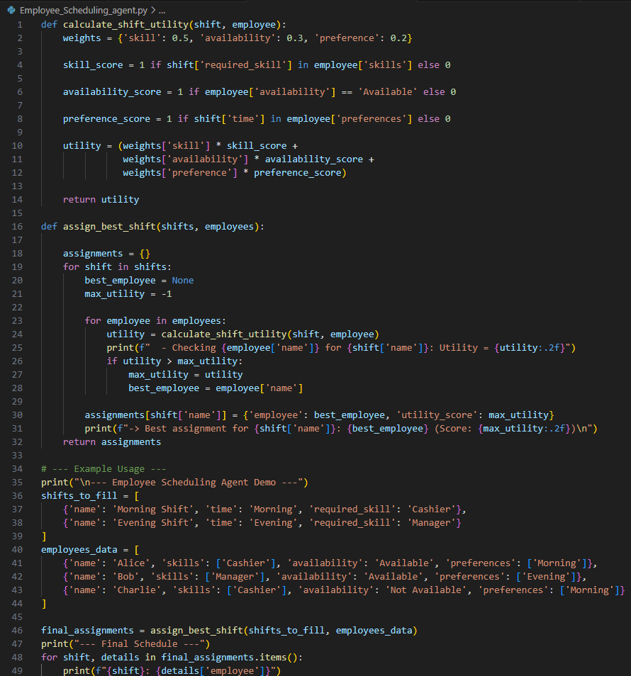

# Shopping Assistant Agent



